Highlands and Islands – Local Innovation Partnership Fund (LIPF)

Regional bid development - Expression of Interest Form

Highlands and Islands Enterprise (HIE) invite expressions of interest for projects that could form part of a competitive bid to the UK Government’s Local Innovation Partnership Fund (LIPF). The application to the fund will be led by HIE. The deadline for expressions of interest is Wednesday 21st January 2026.

This is a call for expressions of interest that describe project ideas – it is not a guarantee that your proposed project will form part of the bid or that you will receive funding. Expressions of interest will be reviewed by a HIE-led independent panel.

If the HIE application to LIPF for £20 million is successful, there will be ongoing consultations with project owners to further develop ideas during the spring and early summer of 2026.

Please use this form to share information about your proposed project. We ask for brief succinct responses, addressing as many of the points as you can. Before you start, please read the annex overleaf.

Please note that your proposal will be read by an assessment panel drawn from the H&I LIPF partnership. Please see HIE’s privacy policy for information on how we will use your data.

Project Owner
Project Name
Location
Estimated Project Value
Private Funding (co-investment) Value

- Project Summary
Project Summary (200 words maximum)
Start Date
Project Duration

- Opportunity and Analysis
In this section describe the opportunity you are looking to exploit or what challenge will your project address
Please address the following points:
- Project description: Summarise what the project is and what it aims to achieve.
- Market opportunity: Describe how the proposed project will address a business need, technological challenge or exploit a market opportunity.
- Regional USP: what additional advantages does location bring to your project.
- Strategic fit: Set out how the proposed project links to priorities for the region, Scotland and the UK – i.e. HIE Strategy, Scottish Government strategies, UK Industrial strategies for clean energy and/or advanced manufacturing.

- Project Owner and Delivery
In this section explain why you are the right organisation / collaborative team to successfully deliver the proposed work
Please address the following points:
- Responsibilities: Highlight the roles of any partners, collaborators, or stakeholders who will support the project’s delivery.
- Experience: Demonstrate the qualifications, skills and experience, and capabilities of the project team, highlighting their track record in successfully delivering similar projects.

- Pathway to Development
In this section describe how your proposed project will take the innovation towards its intended user(s) or market(s) – i.e. commercialisation
Please address the following points:
- Development plan: Explain how the proposed project will lead to the development or deployment of a new or improved product, service, technology, dataset/model.
- Timeline and phasing: Outline project start and end dates, with key milestones and deliverables, and how it will be delivered within the 5-year timeframe of the LIPF
- You could include a Gantt chart or other visual timeline showing key project phases, milestones, and timelines for delivery

- Local Economic Impact
In this section describe the intended uplift in business growth and/or productivity because of the project and how this could impact on local / regional communities
Please address the following points:
- Outputs: Provide an overview of the economic benefits delivered by the project, including job creation, productivity improvements, and gross value added (GVA).
- Impact: Quantify the potential impact where possible, using data or projections to show how the project will affect local employment, business activity, or other key metrics
- Outcomes: Describe how the project will contribute to local or regional economic growth and align with economic objectives in the Highlands and Islands region, including Community Wealth Building
- Consider using output/metrics tables: providing evidence on how the outputs and impact have been calculated for each project.

- Risks
In this section describe the main risks for this project
Please address the following points:
- Primary risks: Identify the key risks associated with project delivery and the strategies in place to mitigate or manage these risks
- Consider using a risk management plan: outlining the identified risks, likelihood and mitigation measures.

- Resources and cost justification
In this section tell us what you need to deliver your proposed project and how much will it cost
Please address the following points:
- Resources required: Provide a breakdown of what is required to deliver the project including staff, funding and other key inputs.
- Co-investment: Demonstrate how the project will leverage follow-on private sector investment to bring future sustainability. This criterion is set out in more detail in the Annex – Technical Guidance below.
- Budget: Present a budget that outlines the cost of each project phase and justifies how the funding will be allocated.
Annex – Technical Guidance

Extracted from https://www.ukri.org/publications/local-innovation-partnerships-fund-guidance/

Funding Criteria
The LIPF is designed to support a broad range of R&D activities that accelerate the conversion of research excellence into new products, services or technologies that deliver impact through by increasing productivity, attracting investment, and creating high-value jobs.
A non-exhaustive list of eligible activities for funding is set out in table 1 below. Key features of R&D activities that will be supported include:
- Projects must meet the criteria on eligible activities and demonstrate how they both support their priority clusters and deliver LIPF outcomes.
- Discovery or ‘blue sky’ research is excluded, but otherwise there is broad flexibility on what can be supported.
- As the programme uses standard CDEL R&D2 funding, both traditional capital expenditure and programme expenditure that can be capitalised under government rules for R&D are in scope, with no specific split required.
- Each project must be clearly justified based on its proposed impact.
- All projects must be delivered within the five-year LIPF timescale, with proposed benefits reflecting a realistic geographical scope which can extend beyond the functional geography of the cluster.
- While benefits are not required to materialise within the five-year period, projects are required to report on their impacts for seven years.
- Proposed activities should not be financially dependent on UKRI funding, either concluding within the programme window or supported by other funds.
Each LIPF partnership will be expected to demonstrate that their portfolio of activities can generate an absolute minimum private to public investment ratio of 1:1 during the delivery phase and 2:1 across the portfolio’s lifespan (7-year reporting period). Ideally, they should demonstrate how they could deliver a ratio of 3:1 over the lifespan. The focus on leveraging private sector activity from the LIPF is particularly important in the longer-term, even if it cannot be achieved at the outset of projects.
The LIPF is also intended to act to de-risk innovation and crowd in additional investment from partners, the private sector and institutional investors. This would encompass upfront industry co-investment right through to follow-on funding, spanning four types of investment, but only non-public funding will count towards the ratios above:
Type 1: Matched / Co-investment. Only non-public sources of funding will be recognised as matched funding. In-kind contributions will not be eligible as LIPF seeks to raise private sector investment.
Type 2: Accompanying. Additional public (but non-UKRI) and non-public investments that support LIPF-funded R&D activity over and above those which are considered eligible costs as part of the grant subsidy.
Type 3: Aligned. Investment in a technology/ research area thematically aligned to, and catalysed by, LIPF-funded R&D activities.
Type 4: Follow-on. The investment to take to market, or exploit, outcomes from LIPF funded R&D activity. This often involves combining with other Intellectual Property or technology to deliver a commercial product.
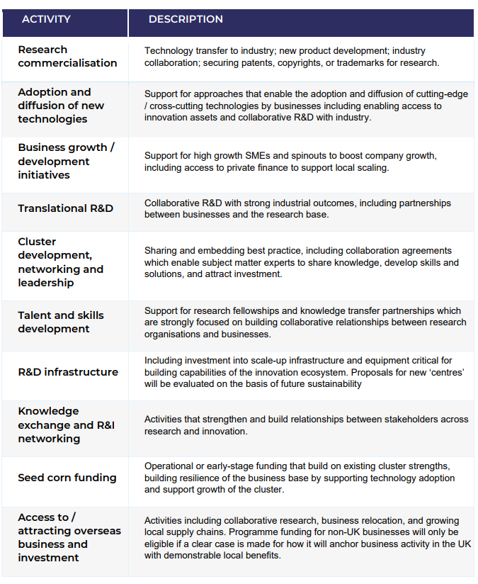
Table 1: Non-exhaustive list of eligible activities the LIPF can fund

